Phase-02- GCP Project and Billing Management

Learning Objectives
• What is the GCP hierarchy
• What is a Project and why it is important
• How Billing Accounts work in GCP
• How to set Budget alerts to avoid unexpected charges
• How to enable required APIs before using services

GCP Hierarchy
In GCP, resources are organized in this hierarchy:
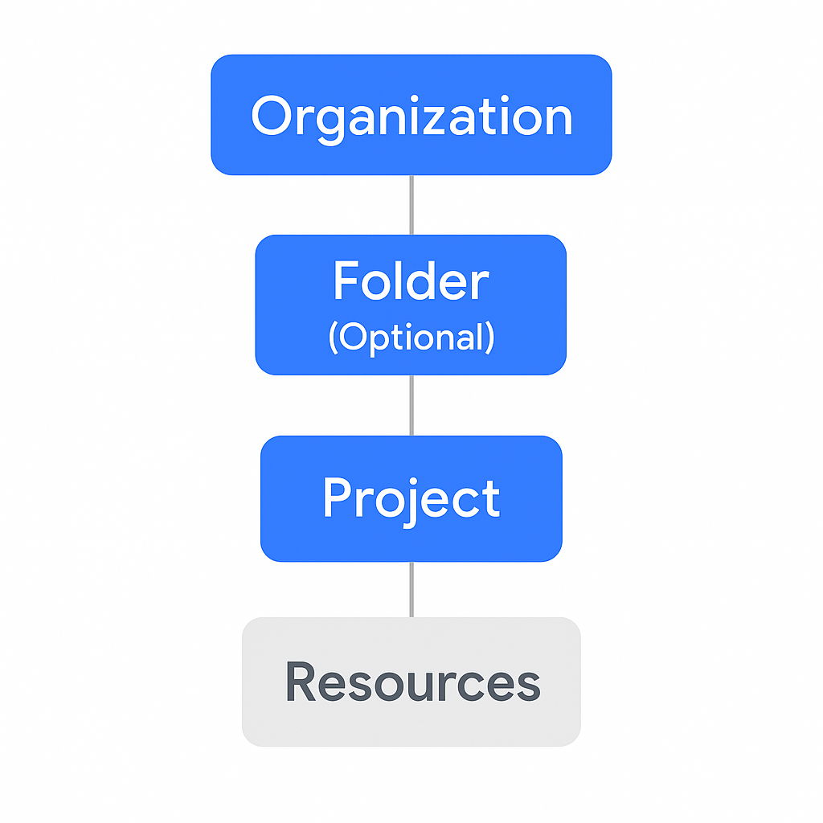
Everything you create must be inside a Project. You cannot create resources without a project.

What is a GCP Project?
A Project is like a separate workspace where all your cloud resources live.
Inside a project, you manage:
• Virtual Machines
• Storage Buckets
• Databases
• IAM permissions
• API access
• Billing usage
Each project has its own billing, IAM roles, APIs, and resources.
Multiple projects can share the same billing account.

Step 1: Create a New Project
1. Open https://console.cloud.google.com
2. Click the Project dropdown at the top
3. Click New Project
4. Give the name: payments-dev
5. Select your billing account
6. Click Create
This project will be used for all upcoming labs.
Note: We do not have access to organization and folders as we are using free-tier account.
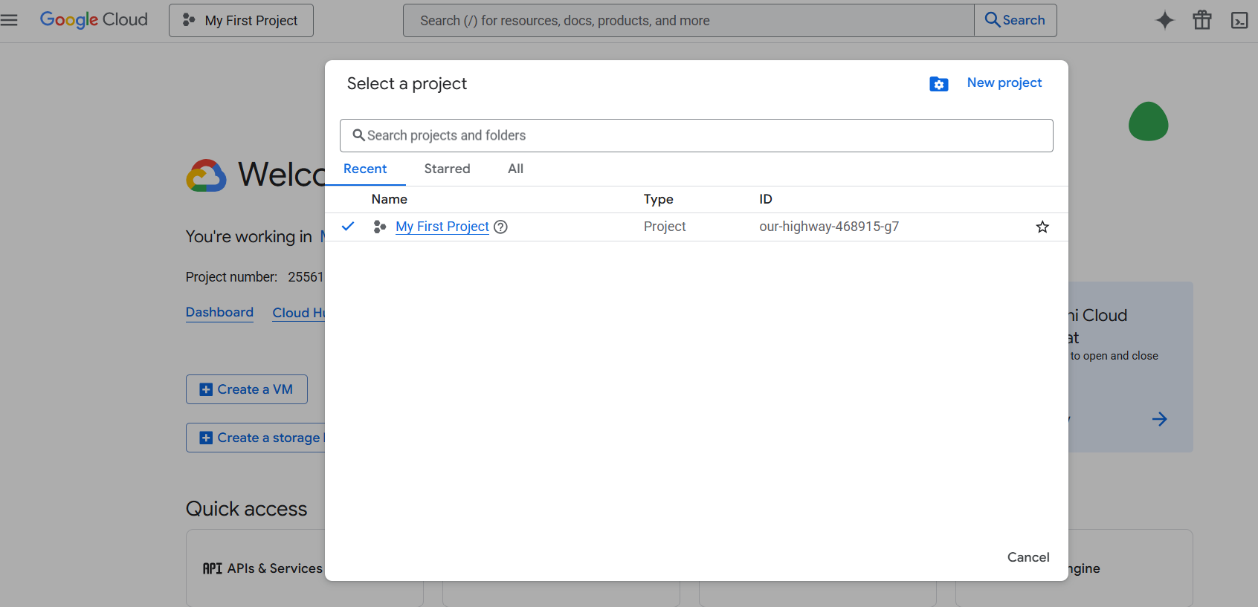
Click on New Project

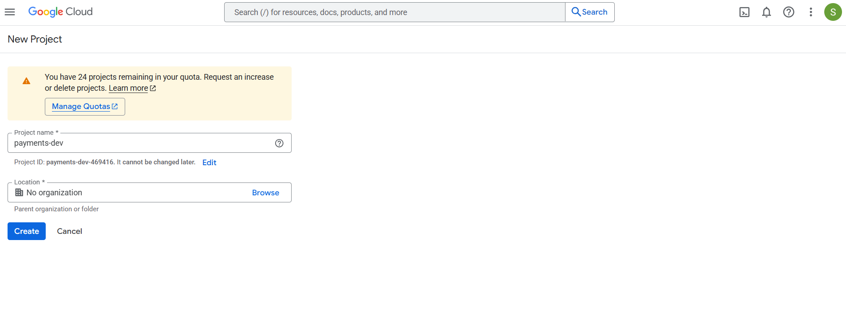
Enter project name and create it, we cannot see organization as we are using free tier account.

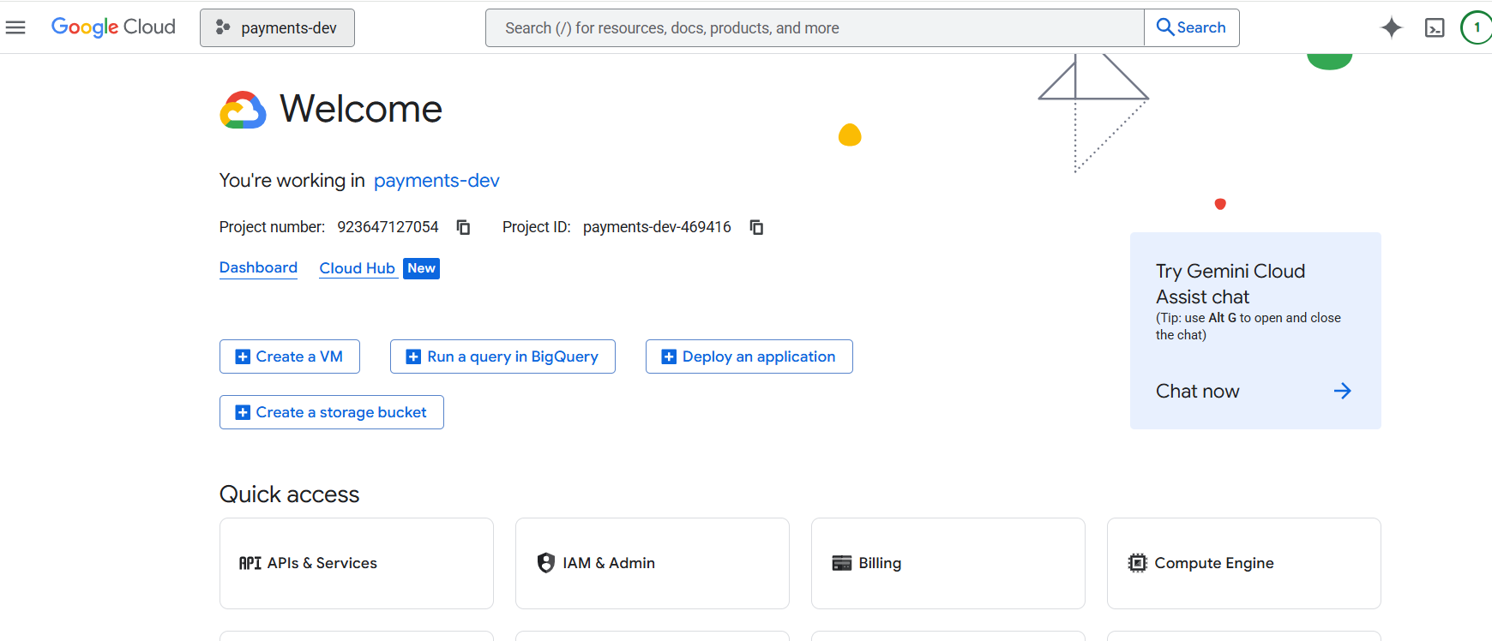

Billing Account in GCP
When you sign up for GCP free tier, a billing account is automatically created and linked to your default project.
Important Points:
• One billing account can be linked to multiple projects
• Budget alerts can be set to track spending
• GCP does not stop services automatically when budget is reached
Now click on three dots and go to billing
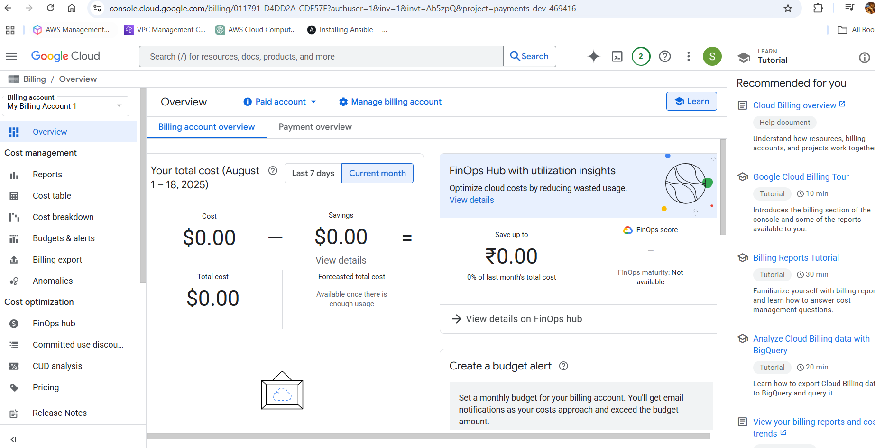

Click on manage billing account
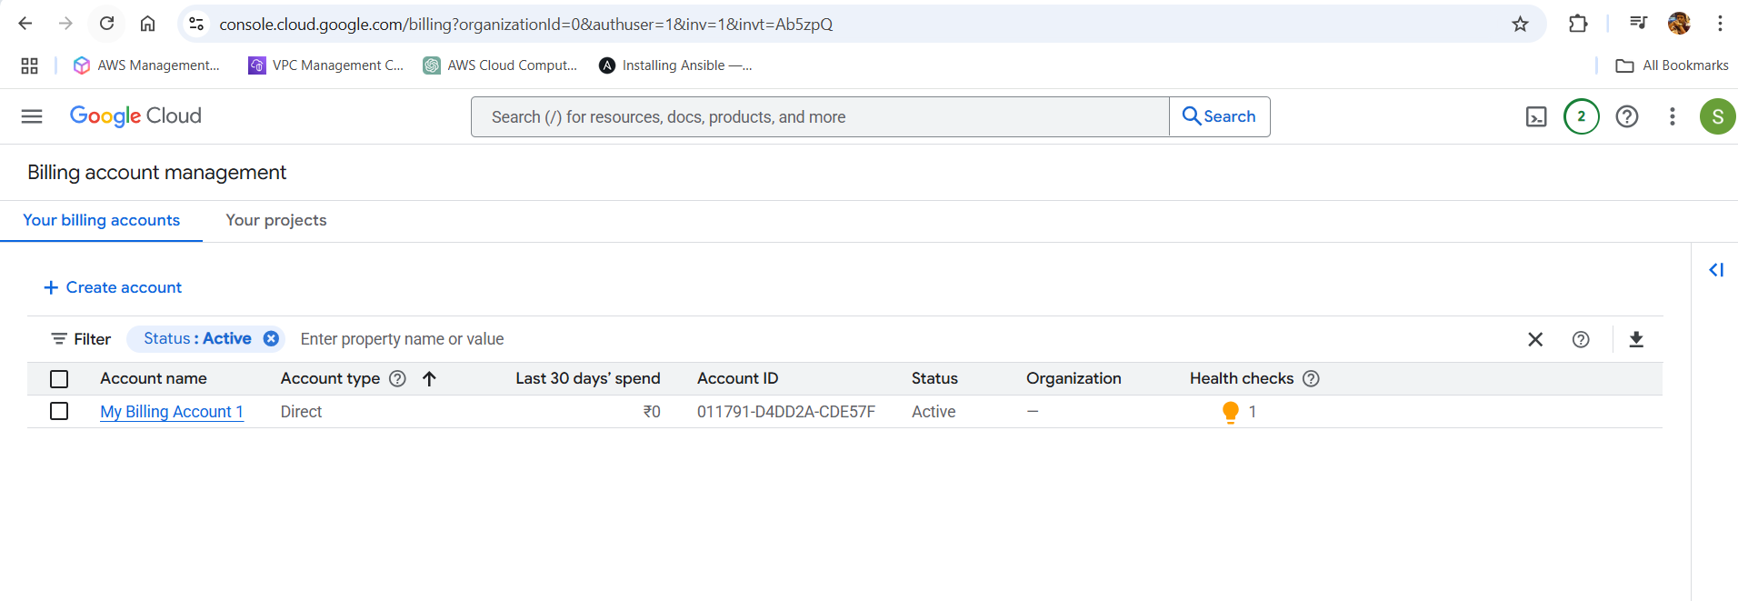

Click on create account and enter below and continue
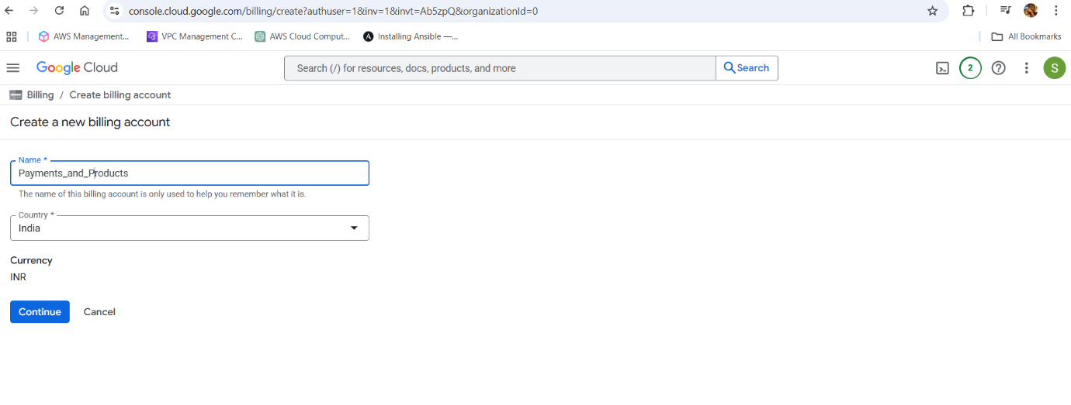

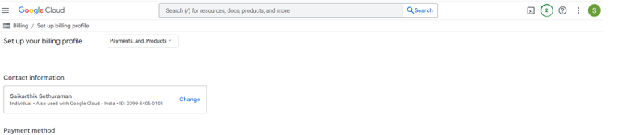

Select payment method and click on submit and enable billing

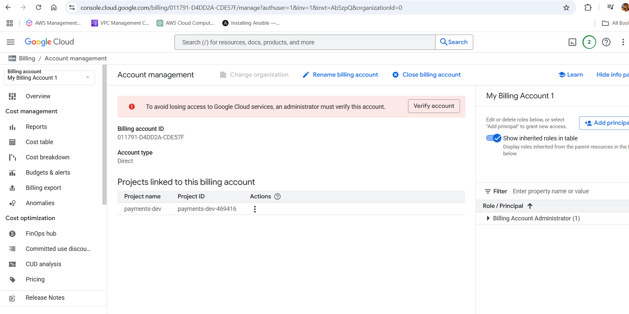

Now go to account managements under billing.
We can see the project linked to the billing account.
We can link multiple projects to one billing account

Step 2: Set Budget Alerts
1. Go to Billing → Budgets & alerts
2. Click Create Budget
3. Set a budget limit (example: ₹1000)
4. Configure email alerts at 50%, 90%, and 100%
Note: Alerts only notify you. They do not stop services.

Go to Budgets & Alerts and click Create Budget
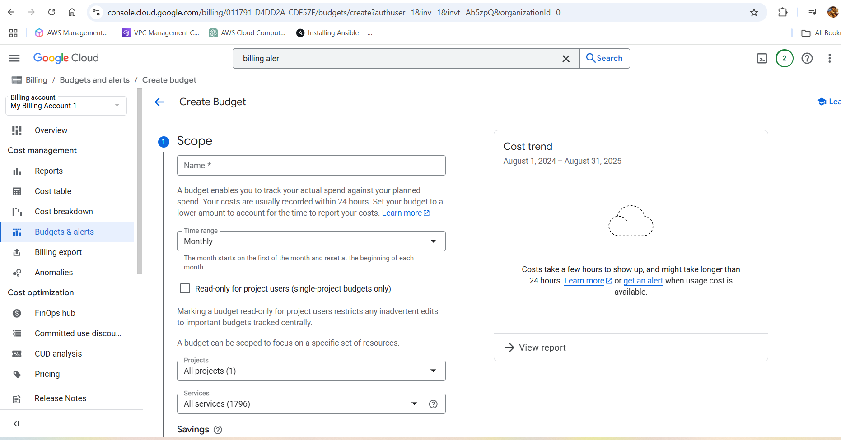

Enter below details and click next

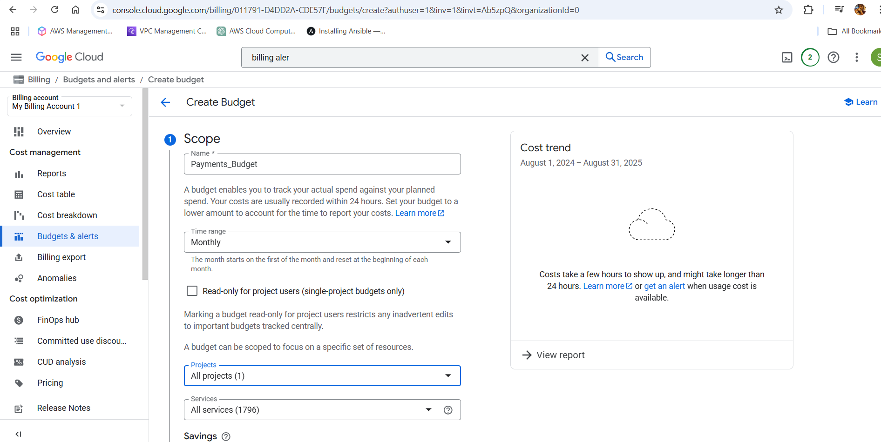

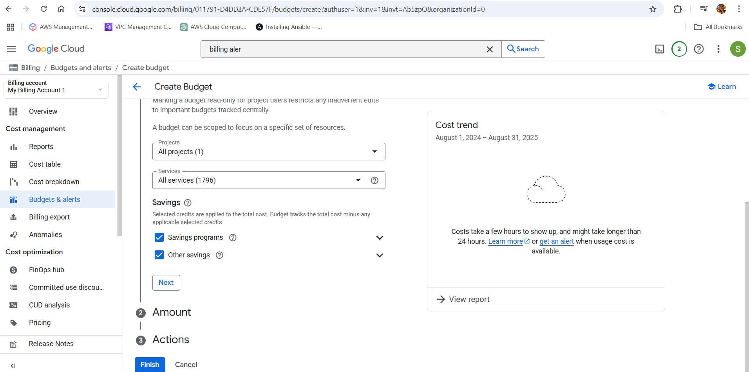

Now select amount and next
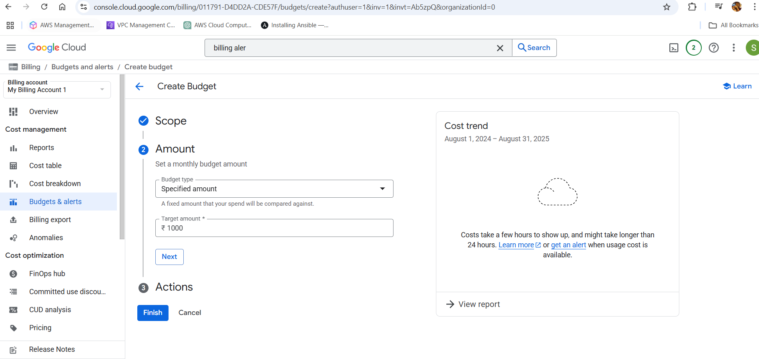

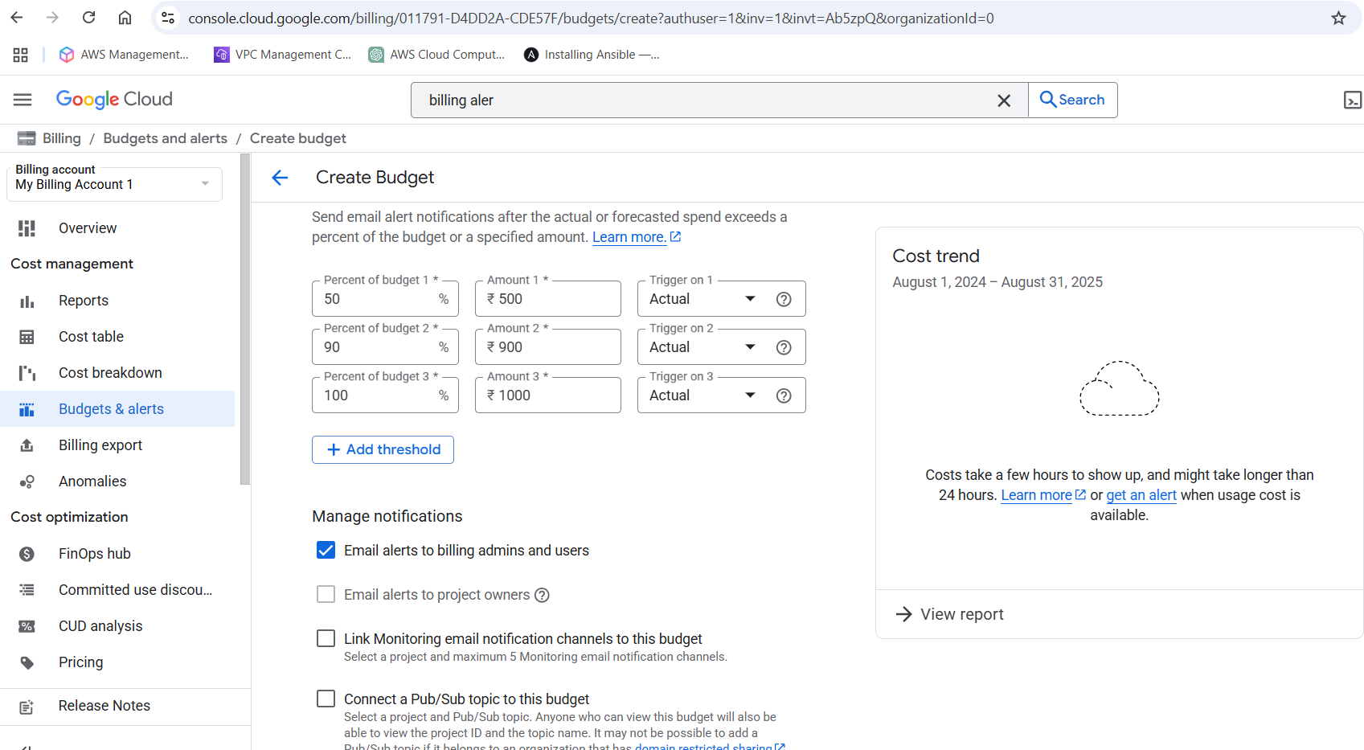

Select actual trigger and enable email alerts and finish
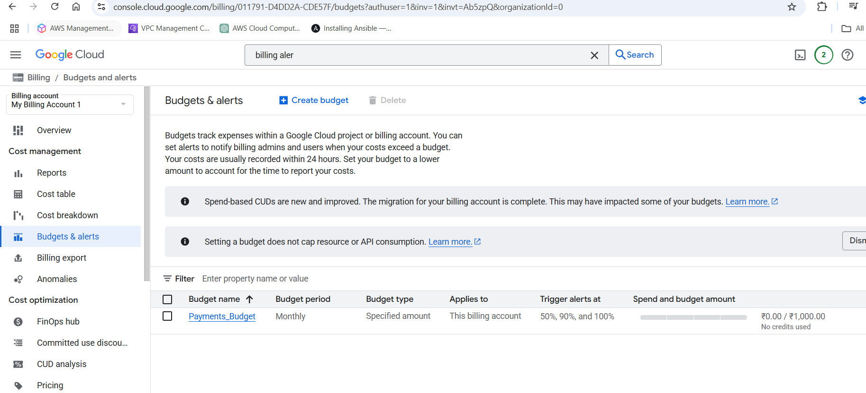

Step 3: Enable Required APIs
APIs to enable:
• Compute Engine API
• Cloud Storage API
• Cloud Logging API
• Cloud Monitoring API
• Cloud Resource Manager API
• IAM Service Account Credentials API
Steps:
- Go to APIs & Services → Library
- Search each API by name and click Enable
Alternatively, use Cloud Shell:
gcloud services enable compute.googleapis.com \
storage.googleapis.com \
monitoring.googleapis.com \
logging.googleapis.com \
cloudresourcemanager.googleapis.com \
iamcredentials.googleapis.com

If we want to create a resource (ex: Compute Engine), we need to enable API.

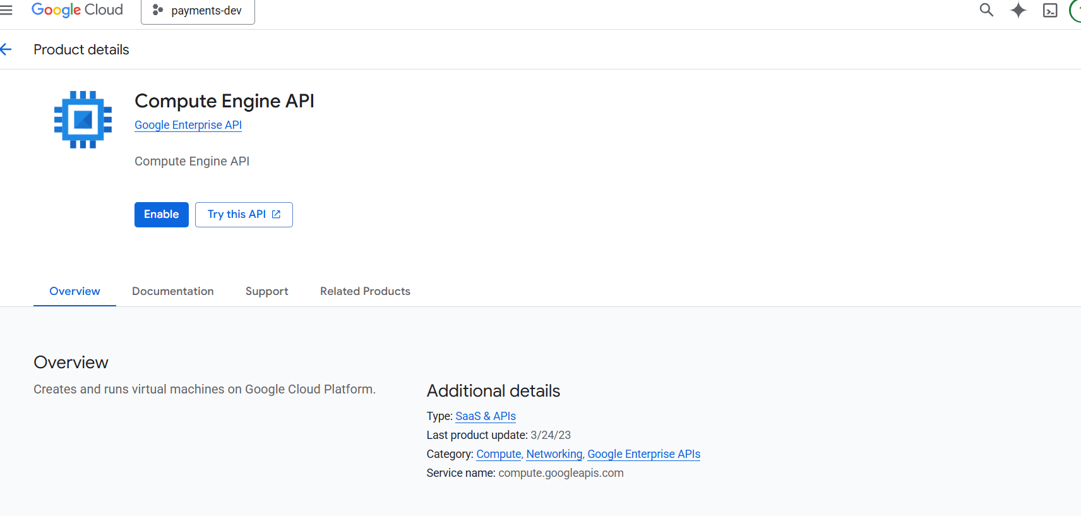

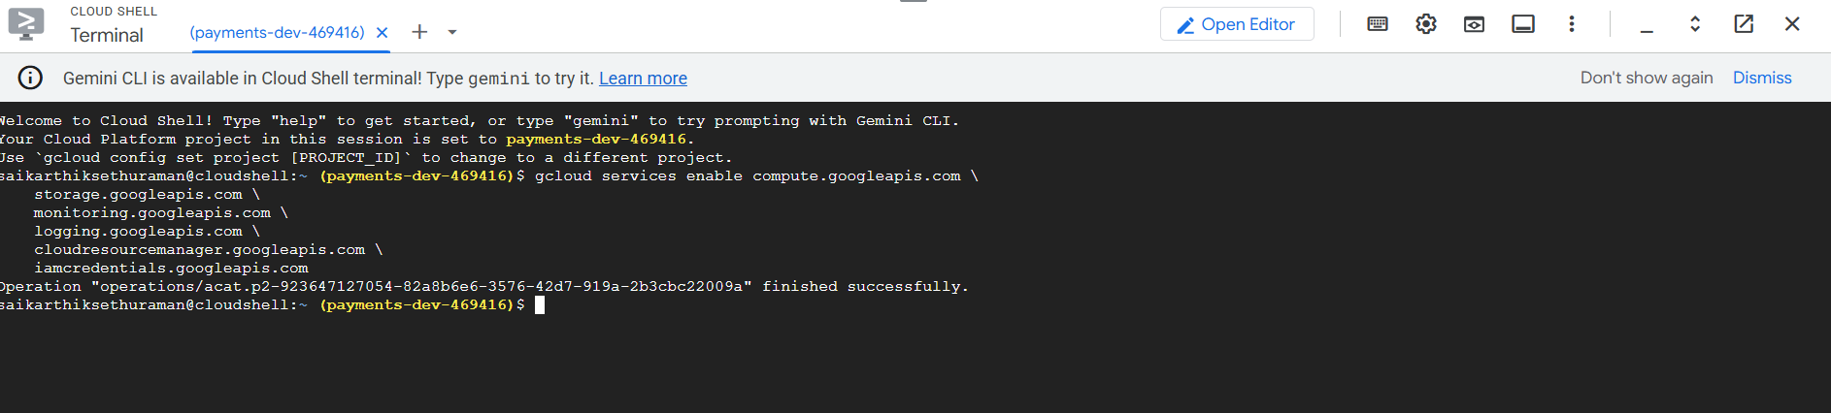

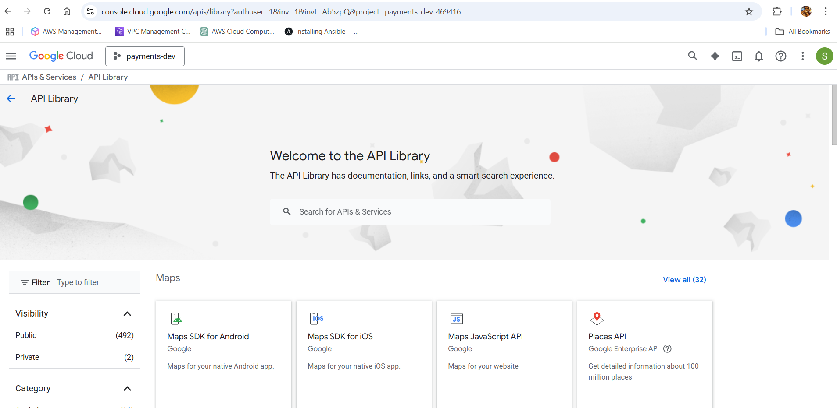

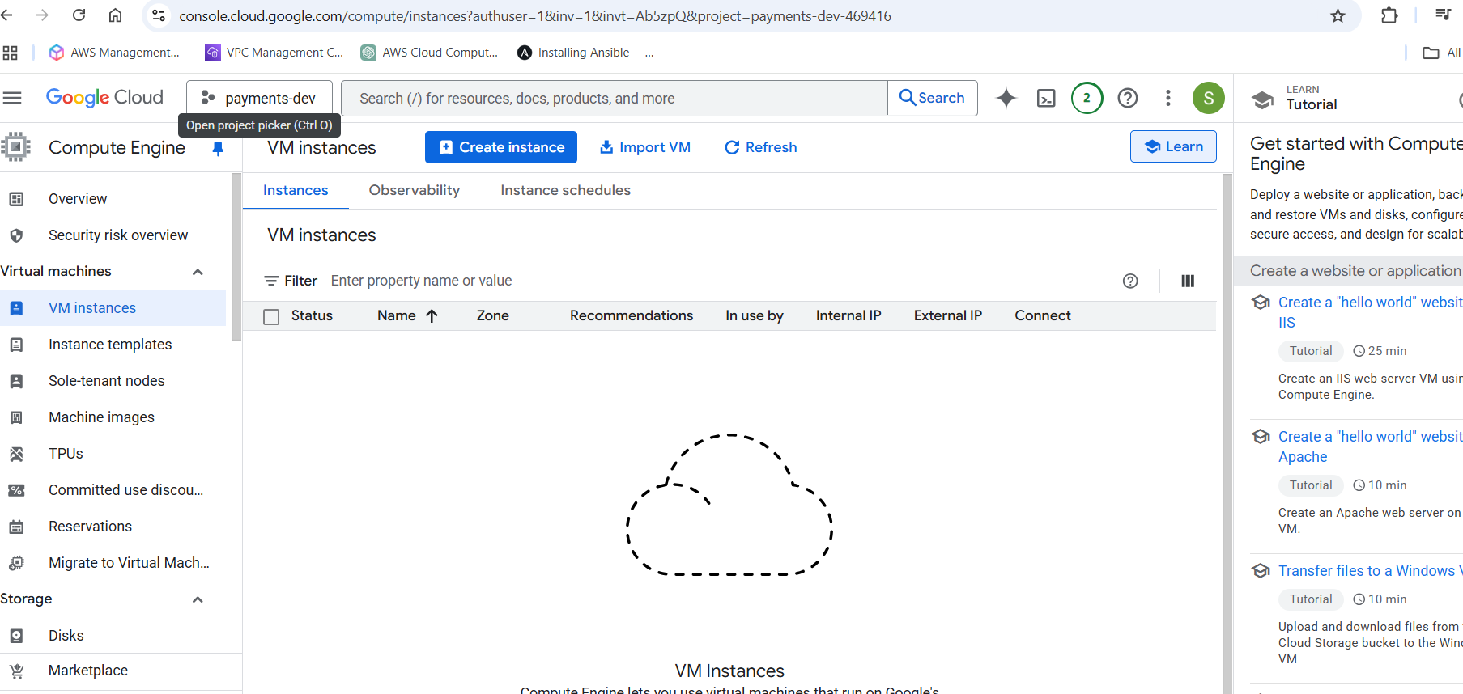

Outcome of Phase-02
By now you have:
• Created a new project
• Linked billing properly
• Set budget alerts
• Enabled core APIs

